
Student Number
Mark /

Chemistry Assessment

Task 3 Term 2 2010 Part 1. Theory
Answers

General Instructions for Theory and Research

•Reading time 10 minutes
•Working time 90 minutes
•Write using black or blue pen
•Write your Student Number at the top of this page
•Board-approved calculators may be used

A data sheet and a periodic table are provided
at the back of the paper.

Total Marks – 34

Part A 7 marks

Attempt Questions (1-7)
Allow about 10 minutes for this part

Part B – marks

Attempt Questions (8-13)
Allow about 40 minutes for this part

Part B – 28 marks

Confidential
Keep Secure

Part A: Multiple Choice: 7 marks
Attempt Questions (1-7)
Allow about 10 minutes for this part

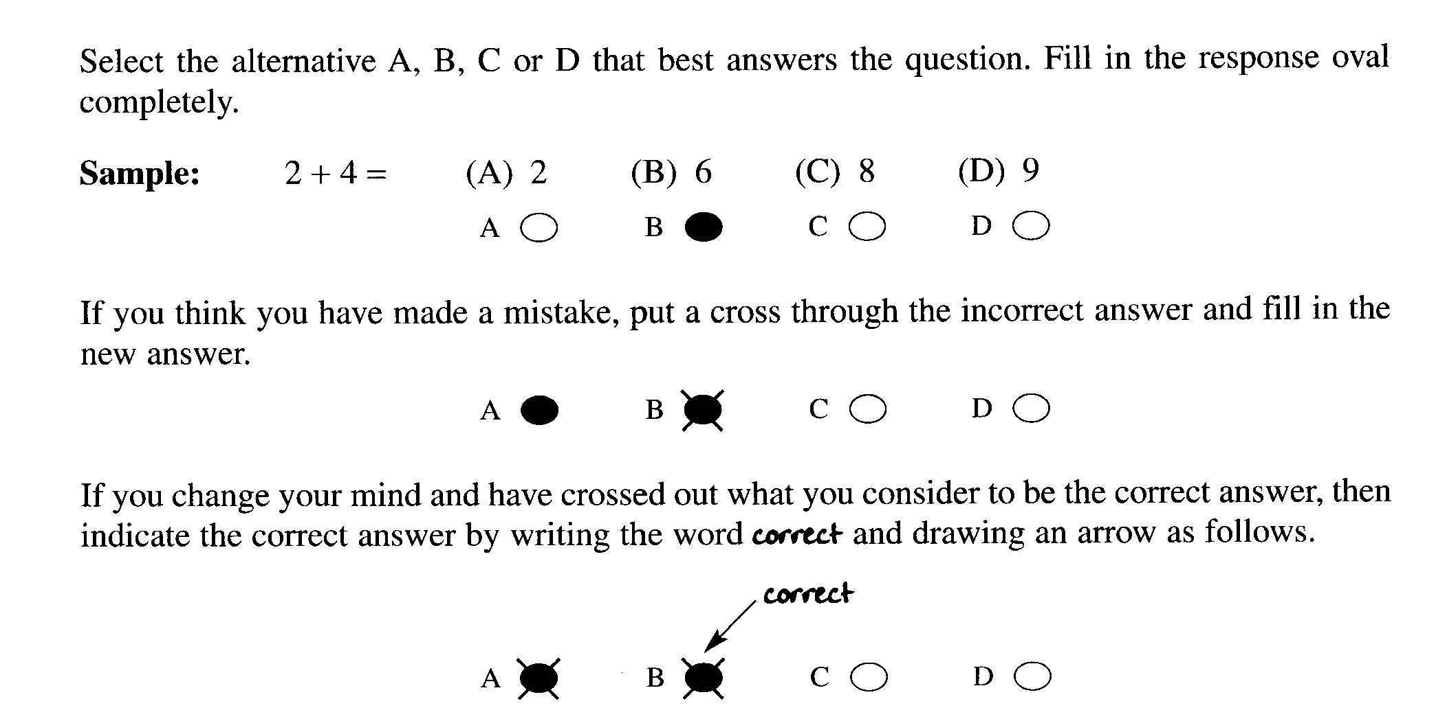

Mark your answers for the multiple choice questions on the multiple choice grid on page -----

1. Which of the following reactions does not involve coordinate covalent bonding?

(A) hydrogen ions with water molecules

(B) gaseous ammonia with gaseous HCl

(C) zinc metal with copper ions

(D) chloride ion with boron trichloride molecule

OUTCOMES: H6, H13, H7

2. What is the main source of the brown haze in city centres in the morning?

(A) ozone reacting with CFCs

(B) car engines

(C) ozone reacting in the presence of sunlight

(D) dust particles stirred up by moving cars

OUTCOMES: H4, H13, H18

3. What is the systematic name for an isomer of the following compound?

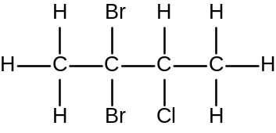

(A) 2 – chloro−3,3−dibromobutane
(B) 2,2−dibromo−3−chlorobutane
(C) 2,3–dibromo–2–chlorobutane
(D) 2–bromo–3,3–dichlorobutane

4. The following gaseous equilibrium is established at high temperatures in the presence of a finely divided nickel catalyst.

CH₄ (g) + H₂O (g) 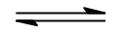 CO (g) + 3H₂ (g) ∆H = +206 kJ molL⁻¹

A particular reaction is carried out using equal amounts of CH₄ (g) and H₂O (g).
Which of the following sets of changes in conditions would lead to the greatest increase in the proportion of the reactants converted to products?

 | Temperature | Pressure
(A) | increased | decreased
(B) | decreased | decreased
(C) | increased | increased
(D) | decreased | Increased

Outcomes : H7, H8

5. The atomic absorption spectrophotometer was developed by Sir Alan Walsh and his team at the CSIRO in the 1950s. Its development was one of the most significant in Australian chemical technology.

What is the advantage of using AAS ?

(A) A fast method for determining the presence of chemical pollutants in waterways.

(B) The first method for determining the concentration of cations in waterways.

(C) A method for determining very low concentration of cations.

(D) A method for determining vey low concentrations of anions in waterways.

Outcome(s): H1

6. A 2.45 g sample of lawn fertilizer was analysed for its sulfate content by reaction with barium chloride solution. After filtration and drying, 2.18 g of barium sulfate was recovered.

What is the % w/w of sulfate in the lawn fertilizer ?

(A) 16.8

(B) 36.6

(C) 46.2

(D) 89.0

Outcome(s): H10

7. Which of the compounds is a halon?

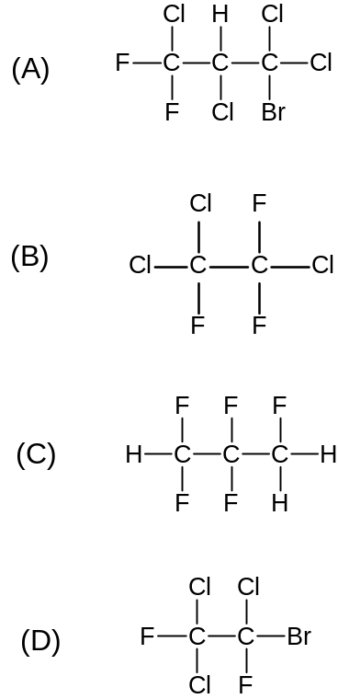

Outcome: H13 Ans D

Part A . Answer grid for multiple choice questions Total ................/7..

1. A O B O C  D O

2. A O B O C l D O

3. A O B O C l D O

4. A l B O C O D O

5. A O B O C l D O

6. A O B l C O D O

7. A O B O C O D l

Total: ……………../7

Part B Free Response Questions

Attempt Questions 8-14
Allow about 40 minutes for this part

Show all relevant working in questions involving calculations.

Question 8 (4 marks)

Draw the Lewis electron dot diagram of ozone and the oxygen molecule, and explain the difference in their reactivity in terms of their structure and/or bonding.

..................................................................................................................................................................

.................................................................................................................................................................

.................................................................................................................................................................

.................................................................................................................................................................

.................................................................................................................................................................

. ...............................................................................................................................................................

.................................................................................................................................................................

.................................................................................................................................................................

Sample Answer

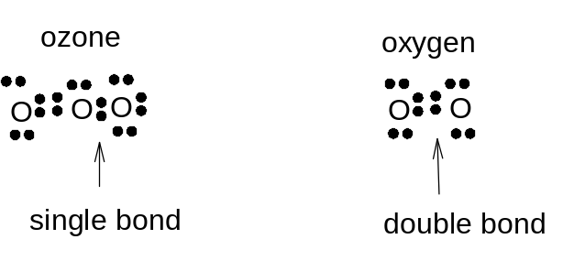

(Rea) Ozone has a greater reactivity than molecular oxygen because of the nature of the bonding in ozone. When ozone reacts the single oxygen – oxygen bond in ozone breaks. When the oxygen molecule reacts, a double bond breaks. (Ex) A single bond is weaker than a double bond and therefore will require more energy to break. The bond to be broken in oxygen is stronger and hence is less easily broken. This makes oxygen less reactive than ozone

OUTCOMES:H5, H6,H13
Criteria | Mark(s)
Lewis electron dot structure for both ozone and oxygen | 2
Relates reactivity to bonding | 1
Relates reactivity to the greater strength of the double bond compared with the single bond | 1

Question 9 (4 marks)

Biochemical oxygen demand is a water quality indicator. Considering this particular indicator, assess the effectiveness and practicality of microscopic membrane filters in purifying and sanitising mass water supplies.

.....................................................................................................................................................................

.....................................................................................................................................................................

......................................................................................................................................................................

......................................................................................................................................................................

......................................................................................................................................................................

.....................................................................................................................................................................

....................................................................................................................................................................

...................................................................................................................................................................

...................................................................................................................................................................

OUTCOMES: H3, H4, H13

Sample Answer:

Microscopic membrane filters are made of thin polymer sheets such PVC, polycarbonate, polypropylene, etc with fixed pore sizes. The pore size can be chosen to suit the particular application required. (D)

The versatility of microscopic membrane filters lie in their ability to remove a variety of impurities according to the pore size of the membrane being used: To remove microorganisms resulting from the abundance of organic material in the water as indicated by a high biochemical oxygen demand, microscopic membranes with small pore sizes can be used. (PS)

Judgement: Microscopic membrane filters are therefore, effective in removing microorganisms from water supply. In terms of practicality they may not be very suitable for mass water supply because of the instrumentation involved.

Criteria | Mark(s)
Description (D) of membrane filters | 1
Use of membrane filters to remove microorganisms via pore size | 1
Judgement- assessment of effectiveness and practicality | 2

Question 10 (4 marks)

The production of ammonia from nitrogen and hydrogen is given by the equation.

3H₂ (g) + N₂ (g) 2NH₃ (g) + heat

 | Concentration of species at 500⁰C
 | [H₂]  (molL⁻¹) | [N₂]  (molL⁻¹) | [NH₃]  (molL⁻¹)
Initial | 1.542 | 0.881 | 0.000
Equilibrium |  |  | 0.281

(a) Write the equilibrium expression for the reaction.

..........................................................................................................................................................

K = [NH₃]²
[N₂][H₂]³

(b) Calculate the equilibrium concentrations of N₂ and H₂ under these conditions. (2 marks)

..........................................................................................................................................................

..........................................................................................................................................................

(b)
[H₂] = 1.1205 molL⁻¹
[N₂] = 0.7405 molL⁻¹

(c) Calculate the value of K for the reaction. (1 mark)

..........................................................................................................................................................

..........................................................................................................................................................

..........................................................................................................................................................

..........................................................................................................................................................

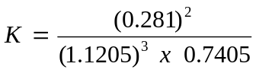

= 0.076

Question 11 (4 marks)

Outline the steps used industrially to maximize the rate and yield of sulfur trioxide from sulfur dioxide. Include a balanced equation in your answer.

.....................................................................................................................................................................

.....................................................................................................................................................................

....................................................................................................................................................................

....................................................................................................................................................................

...................................................................................................................................................................

...................................................................................................................................................................

...................................................................................................................................................................

...................................................................................................................................................................

Outcomes : H8, H10

Sample Answer

The production of sulfur trioxide from sulfur dioxide is carried out industrially in the contact process.
The conditions used industrially are 500⁰C, V₂O₅ catalyst and 1.5 - 2 atm of pressure.

2SO₂(g)+ O₂(g) ↔ 2SO₃(g) + heat

The high temperature is a compromise as the forward reaction is exothermic and a high temperature will favour the reverse reaction. However a compromise temperature is used to effect a moderate yield but at a faster rate, as temperature increases the rate of the reaction.
Although high pressures would favour the forward reaction as there are less gas moles on the right side (3:2) (Le Chatelier’s principle), high pressures are very expensive and sufficient yield is achieved at low pressures (1.5-2 atm)
Faster rate is achieved with the use of the catalyst V₂O_{5.}

Marking Criteria | Marks
- Uses Le Chatelier’s principle to justify one set of reactant conditions  - Identifies that the reaction is exothermic and explains the effect of a change in temperature on reaction yield.  - Writes a balanced chemical equation  - Identifies the catalyst used to maximize rate | 4
- Uses Le Chatelier’s principle to justify one set of reactant conditions  - Identifies that the reaction is exothermic and explains the effect of a change in temperature on reaction yield.  - Writes a balanced chemical equation | 3
- Uses Le Chatelier’s principle to justify one set of reactant conditions OR  - Identifies that the reaction is exothermic and explains the effect of a change in temperature on reaction yield OR  - Any TWO from the marking guidelines below | 2
- Identifies that the reaction is exothermic OR  - Writes a balanced equation for the second step in the Contact process OR  - States Le Chatelier’s principle OR  - Identifies that adding a catalyst increases reaction rate OR  - Identifies that an increases in the concentration of either reactant will increase the yield. | 1

Outcomes : H7, H8, H10, H14

Question 12 (6 marks)

Water samples from oyster farms are regularly checked for lead ion contamination using AAS.
Outline how the analysis of lead ions in the water can be done using AAS. Include a labeled schematic diagram of the AAS instrumentation.

……………………………………………………………………………………………………………...

……………………………………………………………………………………………………………...

……………………………………………………………………………………………………………..

……………………………………………………………………………………………………………..

……………………………………………………………………………………………………………..

……………………………………………………………………………………………………………..

……………………………………………………………………………………………………………..

……………………………………………………………………………………………………………..

……………………………………………………………………………………………………………..

……………………………………………………………………………………………………………..

……………………………………………………………………………………………………………..

……………………………………………………………………………………………………………..

……………………………………………………………………………………………………………..

……………………………………………………………………………………………………………..

……………………………………………………………………………………………………………..

Sample answer:

Marking Criteria | Marks
Diagram with clearly labeled lead light source, atomized sample through flame, monochromator and detector AND written explanation of how this works AND outline of procedure for the preparation of std solutions, calibration curve and testing of water sample. | 7
One of the above missing | 6
Two of the above missing | 5
Three of the above missing | 4
Four of the above missing | 3
Five of the above missing | 2
Six of the above missing | 1

Analysis scheme for lead ions by AAS:

1. Rough concentration of lead ions in the sample is determined.
2. A series of standard lead ions solutions encompassing the expected concentration of lead ion (done in step 1) in the sample are prepared.
3. The sample and standard solutions are passed through the AAS and the absorbance readings noted.
4. A calibration curve is constructed and the concentration of the lead ion in the sample read off the calibration curve.

Schematic diagram of instrumentation

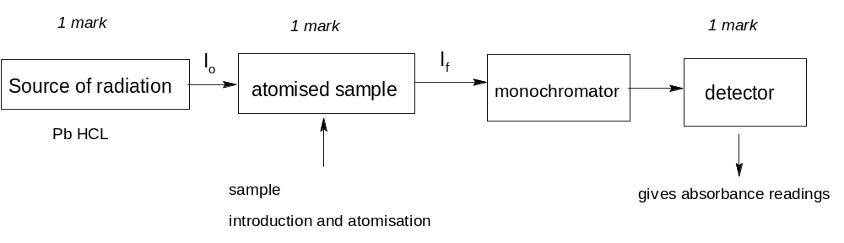

Question 13 (5 marks)

Use a flow chart to show the separation of a mixture consisting of CO₃²⁻, PO₄³⁻ and Cl⁻.
Include in your flow chart the reagent(s) required and the observable result for each ion.

Sample Answer:
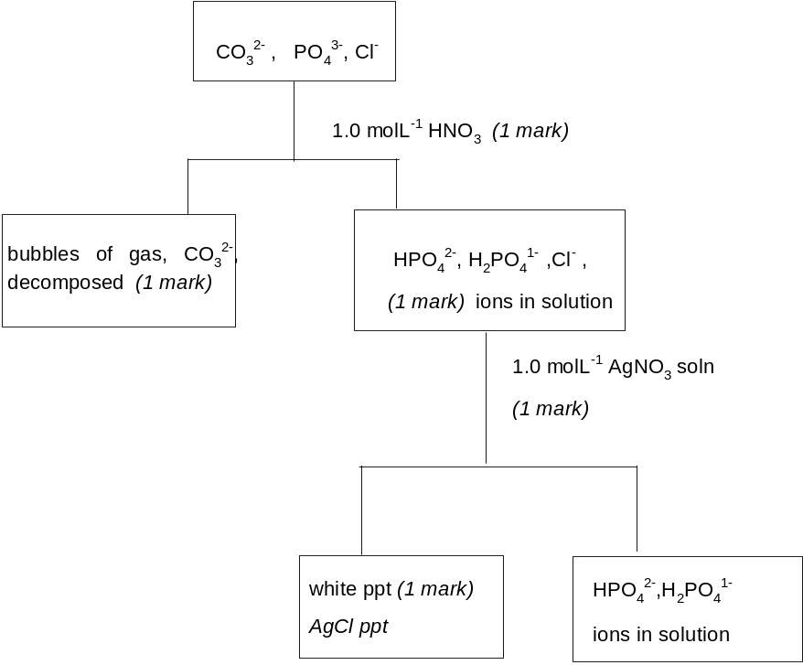
Correct test for identification of phosphate ion
Eg add ammonium molybdate produces a
yellow precipitate

Marking Criteria | Mark
Clearly labeled flow chart diagram showing reagent(s) and correct identification for each ion and showing the separation of the ions. | 5
Any one of the above missing | 4
Any two of the above missing | 3
Any three of the above missing | 2
Any four of the above missing | 1

End of Theory Test

